Author: Hilda-Tabitha Njock
Data Transformation & Preprocessing
A dataset that we received was in the text format and there are four text files in the data folder. Liste 10008 contains Untersuchungen mit Termin alle Felder(BRN) data, liste 10223 has Alle Un-tersuchungen data, liste 10224 contains Terminübersicht nach Status, Raum und Datum alle Feld-er data, and liste 10225 has data related to Stammdaten Untersuchungen mit OPS alle Felder. All of these data files are in the text format and data files also consist of the repeated and null columns or attributes. So, I had to preprocess and transform the data in a readable format.
First, I have transformed all data files into excel files while using Get Data under the Data tab in Microsoft Excel. In the following section, you can find the complete procedure of data transformation in Excel.
Data Transformation
Figure 1 shows the step-by-step process of data read in excel. First, I opened the excel file and clicked on the Data tab, selected Get Data under the Data tab. There are multiple options under Get Data and I have selected From File. Under the From File, I have selected From Text/CSV, when we clicked on it, it demands data from the system.
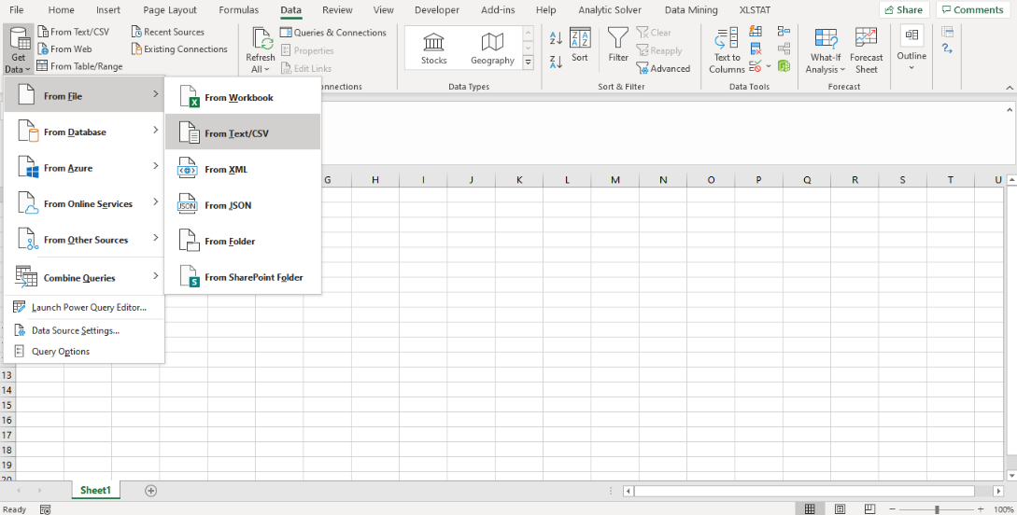
Figure 1. Read Data
When clicking on the From Text/CSV file, I selected the text file from the system as figure 2 represents.
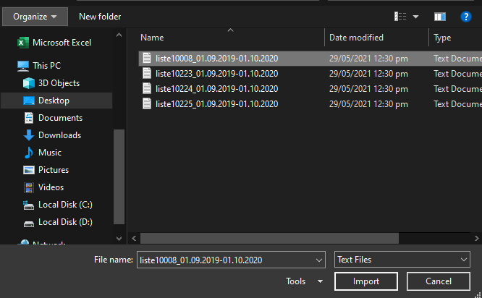
Figure 2. Select file from folder
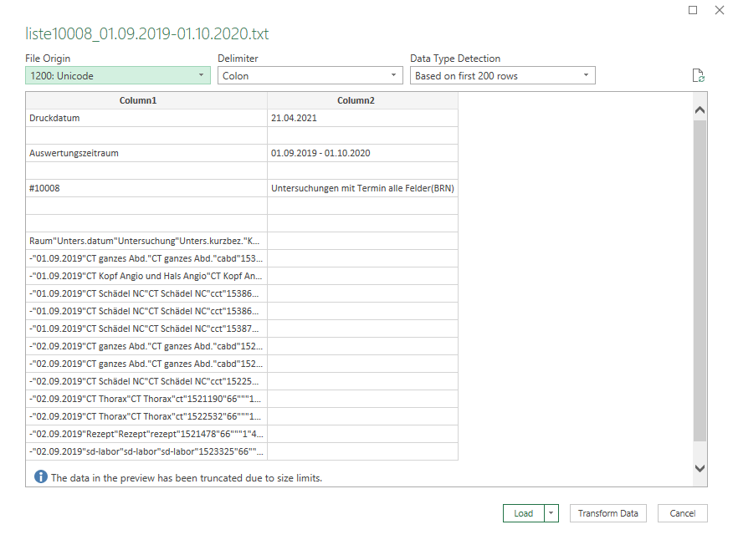
Figure 3. Load Data into Excel
After selecting the file, I loaded the data into excel and the data will combine in a single excel column. As you can see in figure 3. 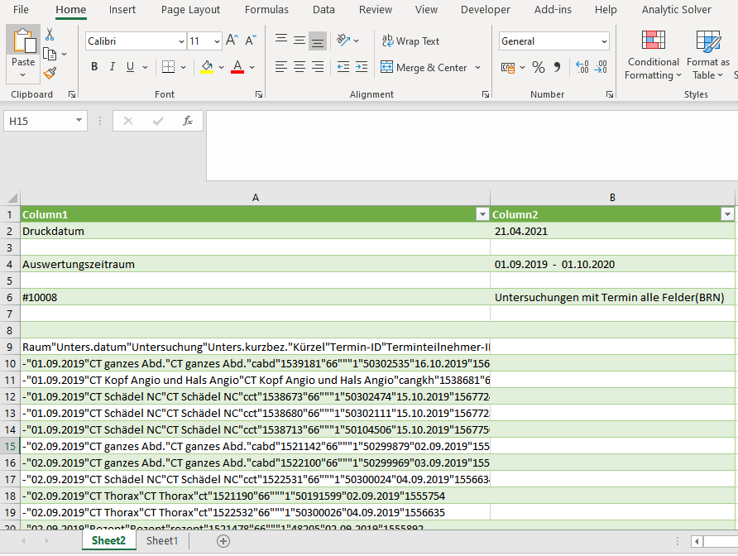
Figure 4. Raw Data Loaded
Figure 4 shows the data after been loaded; in this figure you can see all the data attributes put into a single column which needs more transformation. Next, I clicked again on the Data tab and select the Text to Column option under the Data tab. Figure 5, 6 and 7 represents the complete process of converting data from a single column to multiple columns based on the data attributes.
There are three steps for transforming data into multiple columns. In step 1, I selected the delimited and click on next. Now we are on step 2, I choosed the other check box and write a single quotation “ in front of the other check box. Now data will split based on the single quotation because in the text file data attributes split with the single quotation. In step 2, the excel data transformation process will read data based on the quotation and split the data into multiple columns in step 3. When clicking on the next, step 3 shows the data into multiple columns which we required.
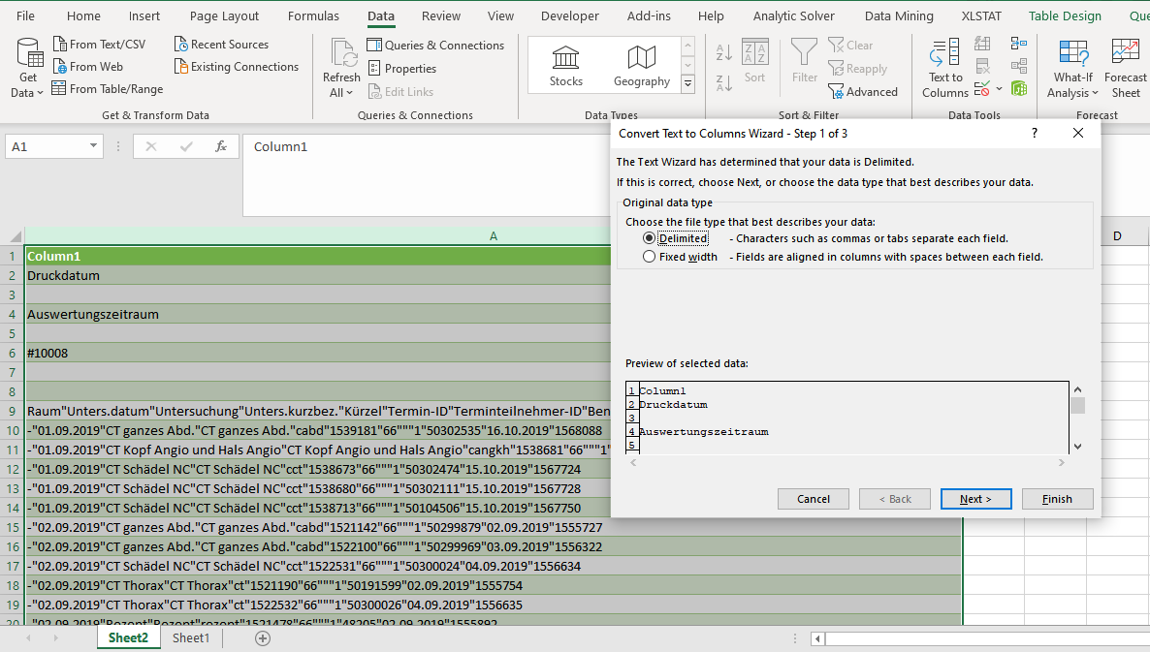
Figure 5. Data Transformation step 1
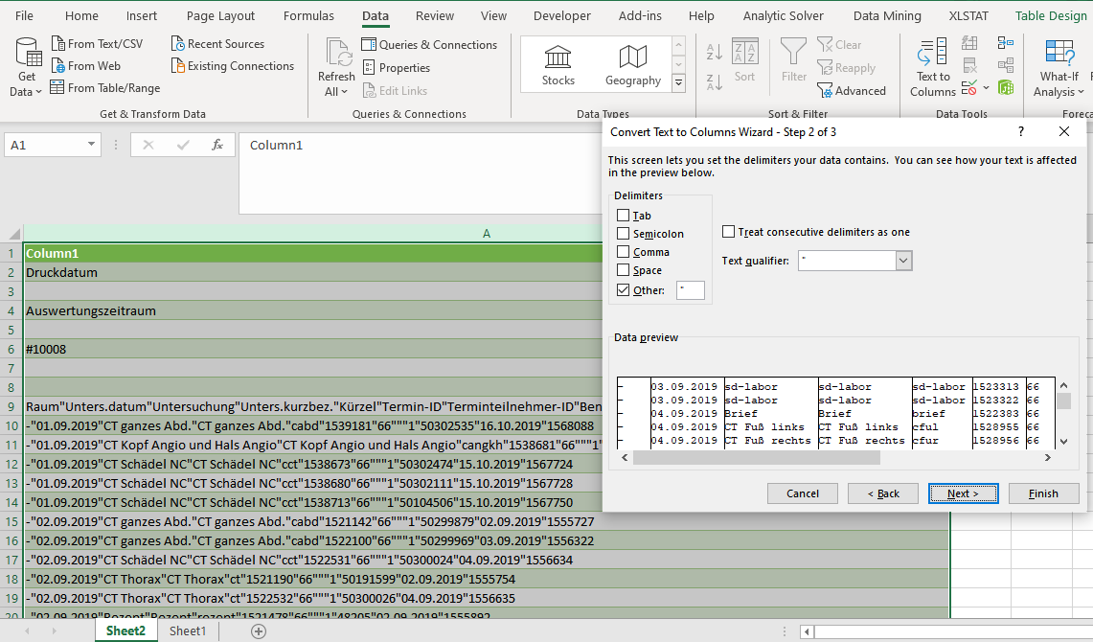
Figure 6. Data Transformation step 2
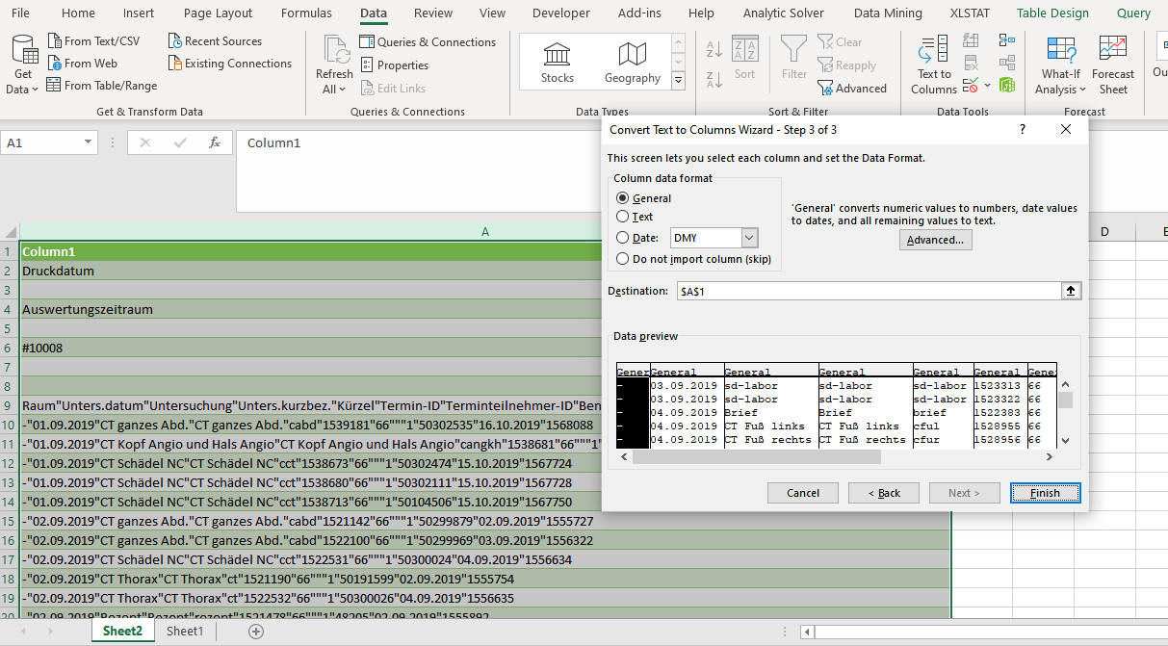
Figure 7. Data Transformation step 3
After transforming the data I clicked on the finish and the data showed in excel as Figure 8. Figure 8 represents the data with null columns and an unnecessary number of rows that need to be deleted.
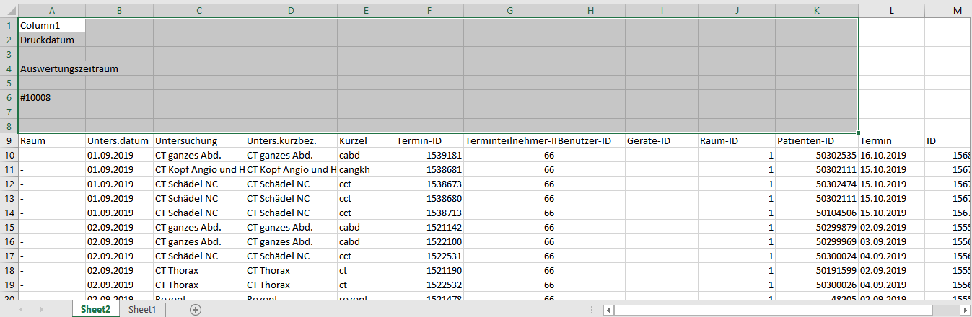
Figure 8. Transformed Data
In figure 9, you can see the transformed data without an unnecessary number of rows, and this the final data but without data preprocessing. In the following section, I have discussed the steps of data preprocessing. Final data contains the missing or Null columns, and repeated numbers of the columns. So, need to clean these columns before performing the data visualization in Tableau.
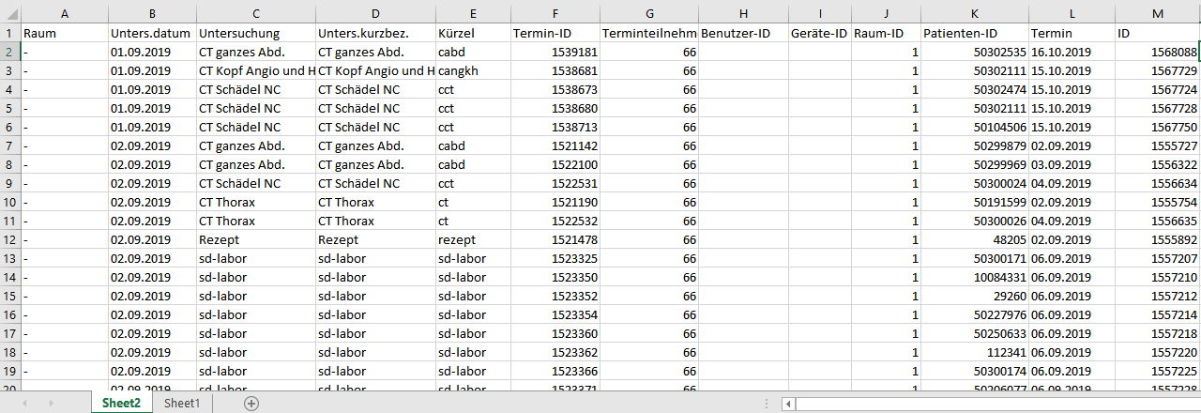
Figure 9. Final Data
Data Preprocessing
This section represents the steps of data preprocessing and interpretation of these steps. Figure 10 shows the highlighted Null column in the 10008 data file. I have removed these columns because these attributes have not any impact on the data analysis and visualization.
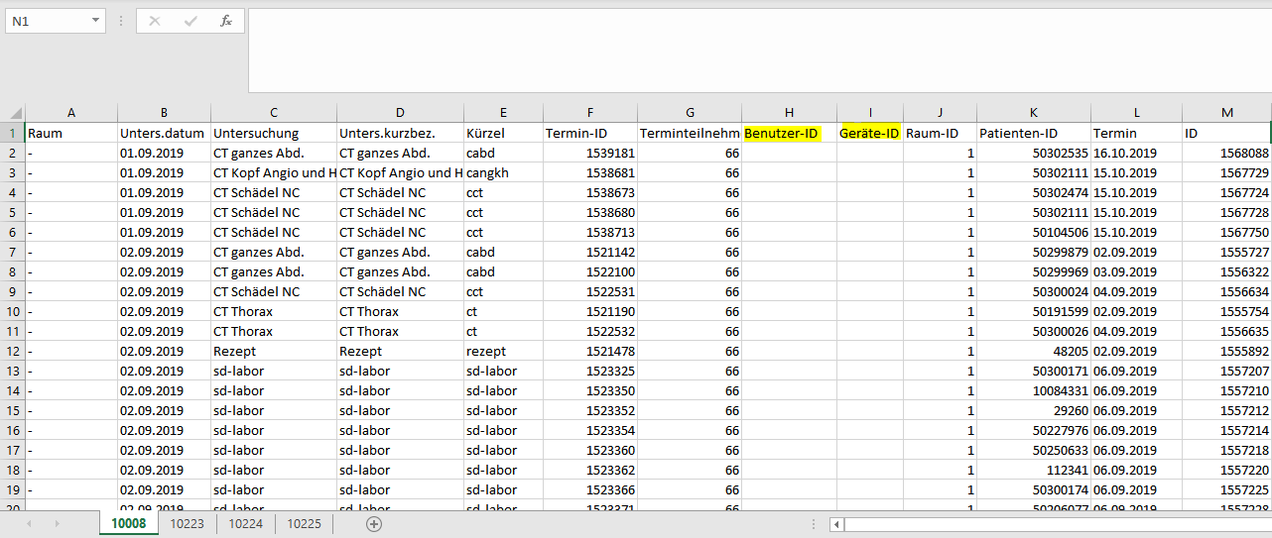
Figure 10. Data 10008 With Null Columns
Figure 11 shows the highlighted Null column in the 10224 data file. I have removed these columns because these attributes have not any impact on the data analysis and visualization
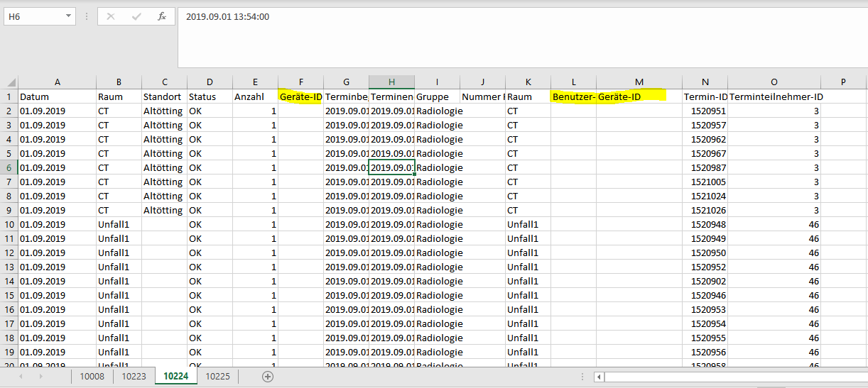
Figure 11. Data 10224 With Null Columns
Figure 12 shows the highlighted repeated column in the 10225 data file. I have removed the repeated columns and we can see Art, Oberbegriff, and Kürzel attributes repeated two times in the data and the Methode variable repeated three times in the 10225 data file. So need to remove these repeated data in the 10225 data file.
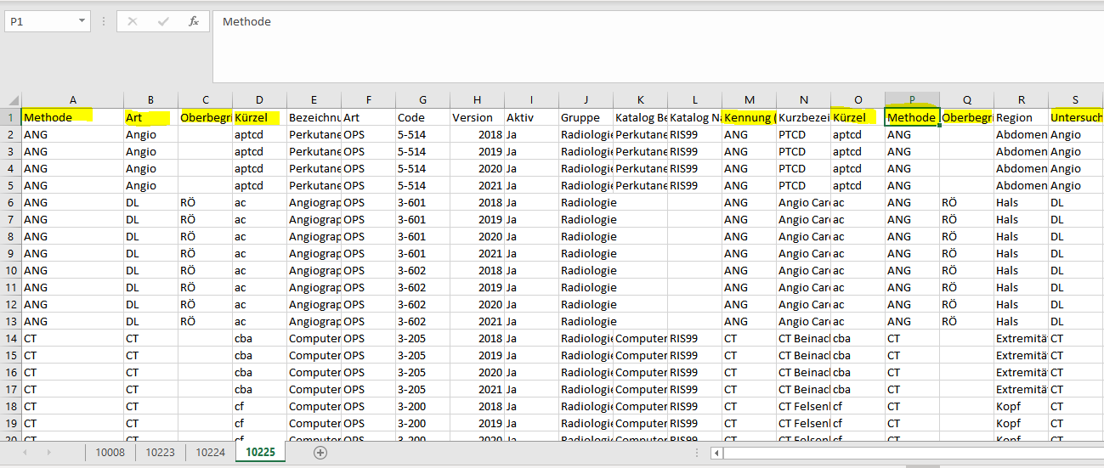
Figure 12. Data 10225 With Repeated Columns

Analysis & Visualization
- How many different customers?
In visualization 1, we can see how many different customers or patients in the dataset. While using the Tableau data visualization tool, I have performed the analysis to find out how many different customers. There are Patient IDs in the dataset, we can find out different patients or customers while using this attribute. There are 35,549 customers or patients in the patient examination data.
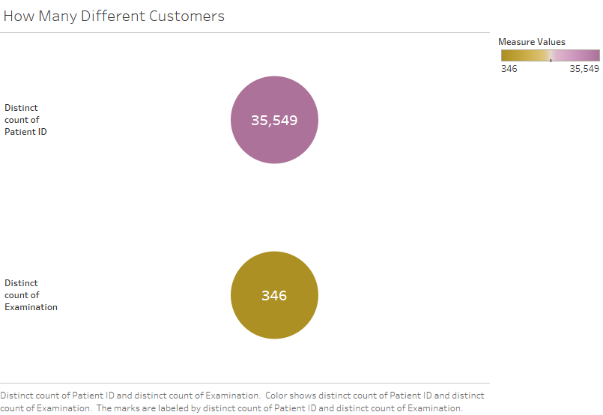
Visualization 1. Different Customers
- What was the busiest day of the week and what was the day with least appointments?
Visualization 2 shows the busiest day of the week and least appointments day in the patient examination dataset. Visualization 3 shows the busiest day of the week and least appointments day by year in the patient examination dataset. Visualization 2 shows Tuesday is the busiest day of the week and Sunday has the least appointments in the overall data. But if we see visualization 3, Tuesday is the busiest day in 2020, Monday is the busiest day in 2019 and Sunday has the least appointments in the 2019 & 2020 data.
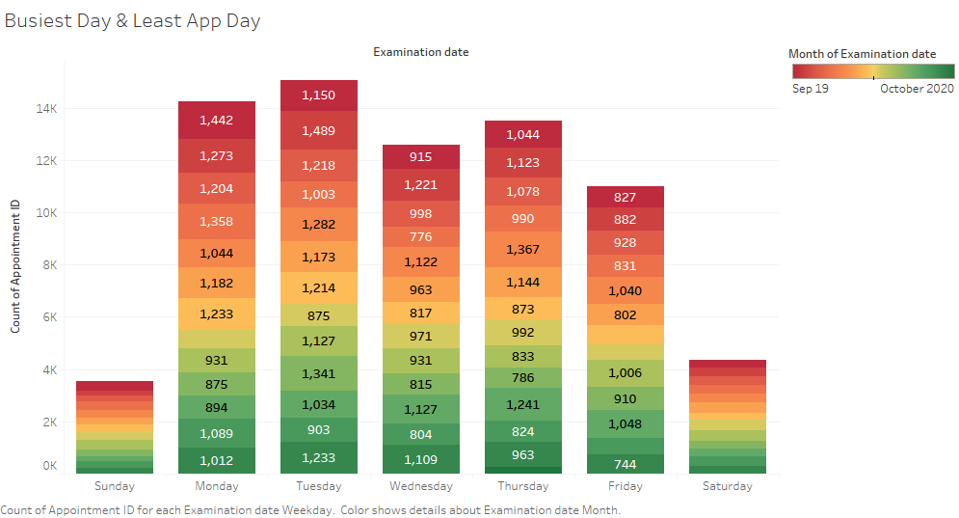
Visualization 2. Busiest Day & Least Appointments

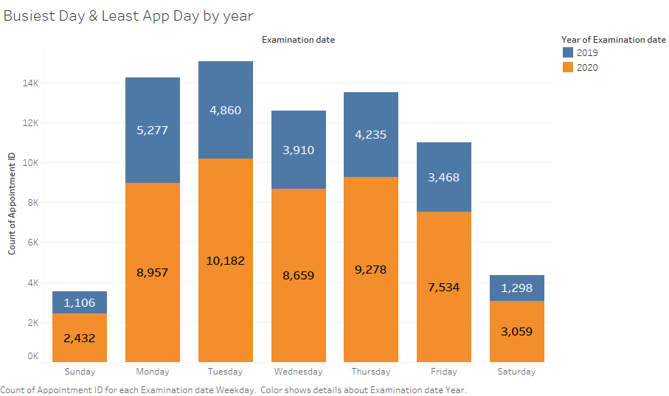
Visualization 3. Busiest Day & Least Appointments by Years

- Which distribution of indications, what was the busiest day of the week?
Visualization 4 shows the distribution of the busiest day with the help of Appointment IDs. Because as many appointments received on a single day, this day will be the busiest day. So, Appointment IDs distribution is the indication of the busiest day of the week.
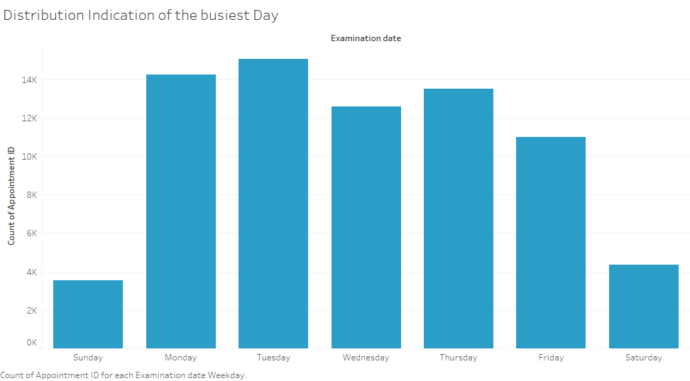
Visualization 4. Distribution Indication of Busiest Day
- What was the most booked radiology examination?
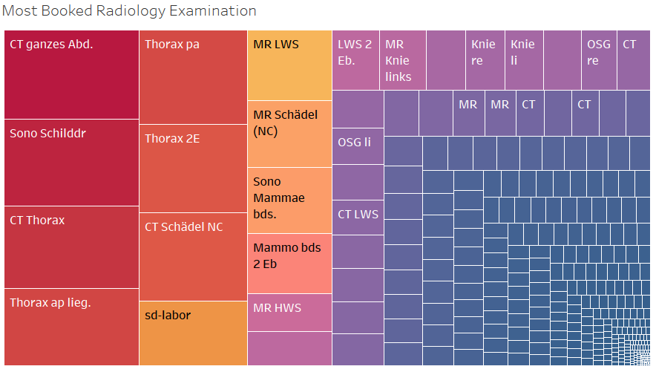
Visualization 5. Most Booked Radiology Examination
Visualization 5 shows the Most booked radiology examination in the patient examination dataset. Visualization 6 represents the most booked radiology examination based on years. Visualization 5 shows CT ganzes Abd radiology examination is the most booked radiology examination in the overall data. But if we see visualization 6, CT ganzes Abd radiology examination is the most booked radiology examination in 2020, Sono Schildder radiology examination is the most booked radiology examination in 2019.
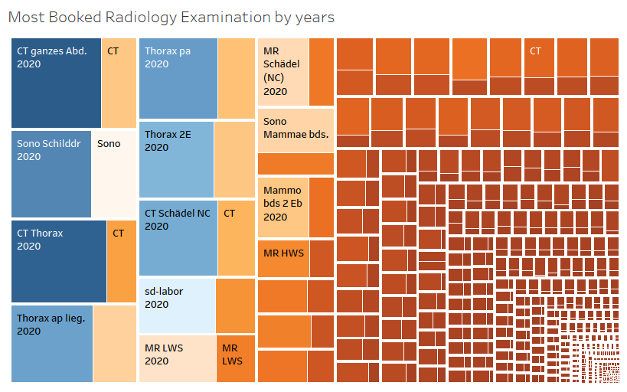
Visualization 6. Most Booked Radiology Examination by Year
- What was the difference in appointment times (this will help us schedule the appointments appropriately to void giving overlapping appointments?
Following visualization in the form of tables represents the difference in appointment times. There is a lot of appointments in the data, so we can’t show the all the difference in the appointment times. Here I have attached some screenshots and I have found the difference in appointment time while using the Datediff function in the Tableau visualization tool. In the visualization of the difference in the appointment time, we can see most of the appointments difference recorded 10, 15, and 30 minutes.
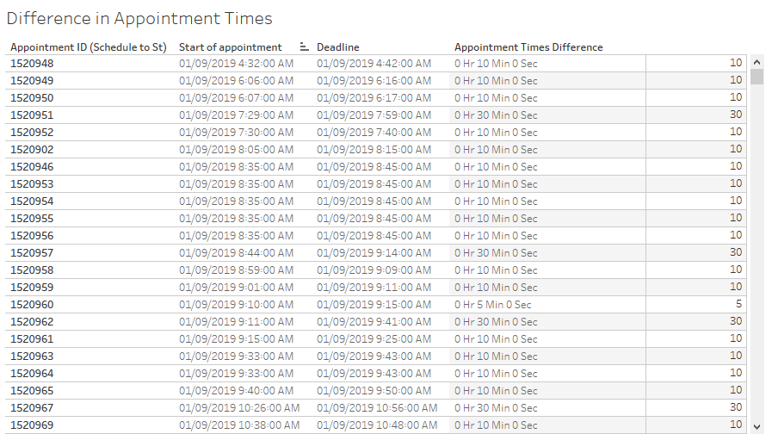
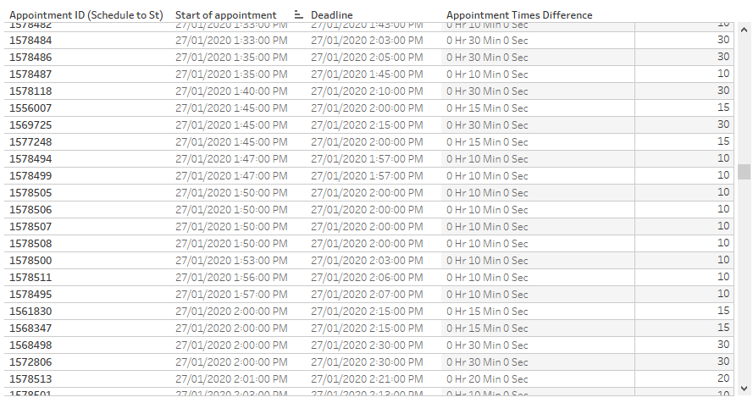
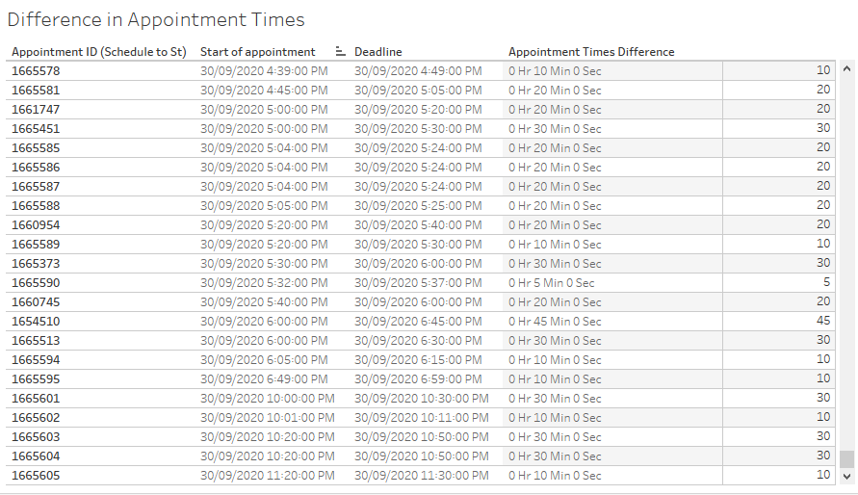
Visualization 7. Difference in Appointment Times

